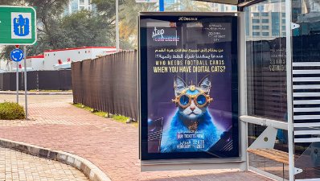Link: https://www.arabnews.com/node/2253191/amp

Medium: Arab News

Country: UAE

Language: English

Date of publication: Februray 22, 2023

Author: Zaira Lakhpatwala

Main image:

ChatGPT outperforms copywriters in STEP Conference’s outdoor adverts

It is why the company plans to continue using the AI tool and get at least one paid account that would be used across the team for “creating, summarizing and explaining content whenever needed,” Dargham explained

DUBAI: In an almost ominous foretelling of what the future might look like for creative industries, ChatGPT, the controversial OpenAI tool, has become the brains behind tech festival STEP Conference’s latest outdoor adverts. The ads feature taglines like “Your money needs a side hustle,” “Save the planet, it’s the only one with good coffee,” “Art on the wall is so last century” and “Who needs football cards when you have digital cats?” among others.Initially, STEP planned to use its agency Mink to create the ads, but both, the agency and STEP, “weren’t satisfied” with the taglines created by the agency and STEP’s internal team, Ray Dargham, founder of STEP Conference, told Arab News. “Then, we gave ChatGPT a try and they came out much better, so we went with it.” The agency, however, was still responsible for designing the outdoor ads based on the taglines generated by ChatGPT. In addition to the outdoor campaign, the company has also used the chatbot for “writing session briefs, creating social posts and writing copy and content in general,” he said. For STEP’s team, the chatbot is “almost like an artificial intelligence assistant that makes them faster and more efficient at their job.” It is why the company plans to continue using the AI tool and get at least one paid account that would be used across the team for “creating, summarizing and explaining content whenever needed,” Dargham explained. One only has to look at movies like “Her” or “Ex Machina” to realize that neither the concept of AI and AI-powered chatbots nor the existential threat posed by them is new. Moreover, experts have argued that AI has created more jobs than it has erased, with one report stating that 85 percent of jobs that will exist in 2030 have not been invented yet. When copywriters are replaced by chatbots, however, it is hard to recognize AI’s job creation capacity. And with other AI tools like Meta’s Open Pretrained Transformer, Microsoft’s Bing and Google’s Bard, the use of chatbots — and the threat to jobs — is likely to increase. Dargham clarified that he does not plan to enforce the use of ChatGPT within the company, “but I think our team will naturally want to use it if they feel like it makes their lives easier. “If you’re a copywriter, you have to constantly churn out copy and it’s not always easy to be creative,” he added.For Dargham, ChatGPT and other AI tools are more complementary than competitive. But does he foresee such AI tools replacing human talent? “I think AI tools will both complement and replace human talent. However, I also think that human talent will find more useful things to do,” he said. He added: “Human creativity will always be extremely valuable.”